

**“Holiday Harvest Fair”**

**St. Alban’s Episcopal Church Women**

**Annual Fund Raising Event**

**301 Caldwell St.**

**(plenty of parking in the rear of the church)**

**(use the rear entrance to the fair)**

**Saturday, November 21, 2009**

**8:30 am to 1:00 pm**

**SPECIAL FEATURE**

***COOKING DEMONSTRATIONS***

***9:00 am** Linda Butt ** Gourmet on the Run – A Wine & Kitchen Shop, Mooresville Plantation***

***10:30 am ** Hilda Gatton ** The Mad Hatter Bakery & Boutique, Downtown Mooresville***

**SILENT AUCTION & RAFFLES**

**FROZEN CASSEROLES & BAKED GOODS**

**SANTA’S WORKSHOP**

**(Advent calendars, olive wood carvings, vintage jewelry)**

This year’s event will focus on the plight of many local individuals and families who now find themselves in need of one of the basics of life – ***food****.*  Proceeds from the November 21st fundraising will go to the Mooresville Soup Kitchen, a local faith-based organization.  In July the soup kitchen averaged 165 meals a day.  The need is increasing daily.  In addition to feeding the hungry, the Mooresville Soup Kitchen provides a shower, washer/dryer and other amenities to help those individuals in need.



**Now we are asking for your help to make this a successful event.**

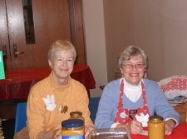

**BAKE SALE Contact:  Camy Brown @** [**bluebird4@mi-connection.com**](mailto:bluebird4@mi-connection.com)**or call 704 237-3644**

Camy will provide recipes for frozen casseroles and coordinate the different kinds of baked goods needed.  Many bakers mean only one person needs to bake one item. Camy and her team will be calling you to provide recipes and suggestions.

**SILENT AUCTION ITEMS Contact:  Rosalie Allen @** [**ro-ro-12@live.come**](mailto:ro-ro-12@live.come) **or call 704 987-2264 or Joan Bischoff @** [**joan@mailingaddress.org**](mailto:joan@mailingaddress.org) **or call 704 892-6425**

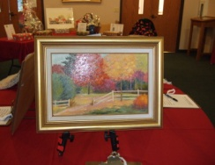

Current items are a vacation home in the mountains, an Oriental rug, an original illustration, and a day on Lake Norman.  Do you have something to add to our auction? Please contact Rosalie or Joan to work out the details.

**RAFFLE ITEMS Contacts:  Elaine Speice @** [**elfsp@aol.com**](mailto:elfsp@aol.com) **or call 704 799-1321 or Janet Martin @** [**lee3janet@aol.com**](mailto:lee3janet@aol.com) **or call 704 663-0448**

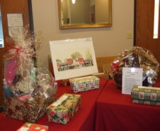

Current items are three baskets and restaurant packages.  More are needed.  Would you like to raffle an evening of babysitting?  Do a fall yard cleanup?  Prepare a dinner?  Please contact Elaine or Janet.

**SANTA’S WORKSHOP Contact Rosalie Allen @** [**ro-ro-12@live.com**](mailto:ro-ro-12@live.com) **or call 704 987-2264**

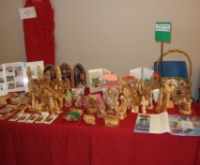

Current items are Advent calendars, olive wood carvings from the Holy Land, vintage jewelry and much more.